

Programme Name: ________**BCS HONS**_______________________________________

Course Code: __**CSC 1403**________

Course Name: ________**Database concept**______________________________

Assignment / **Lab Sheet** / Project / Case Study No. _**5**___

**Submitted By: Submitted To:**

Student Name**: Dipesh Tha Shrestha** Faculty Name**: Amar Subedi**

IUKL ID: Department**: PO**

Semester**: Second Semester**

Intake**: September 2019**

1. **Create table patient  
   Define:** It is used to create table named patient

**Output:**

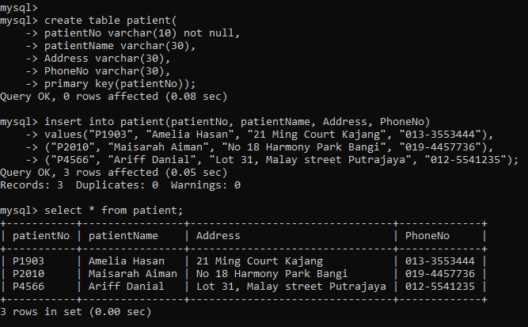

1. **Create table appointment**

**Define:** It is used to create table named appointment  
**Output:**

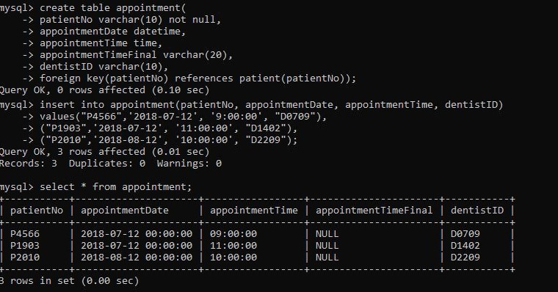

1. **Create table Dentist  
   Define:** It is used to create table named Dentist  
   **Output:**

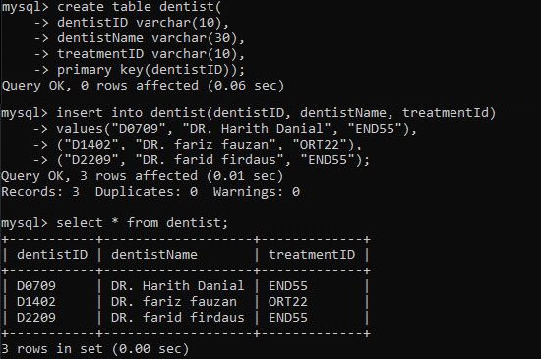

1. **Create table treatment**  
   **Define:** It is used to create table named treatment;

**Output:**

